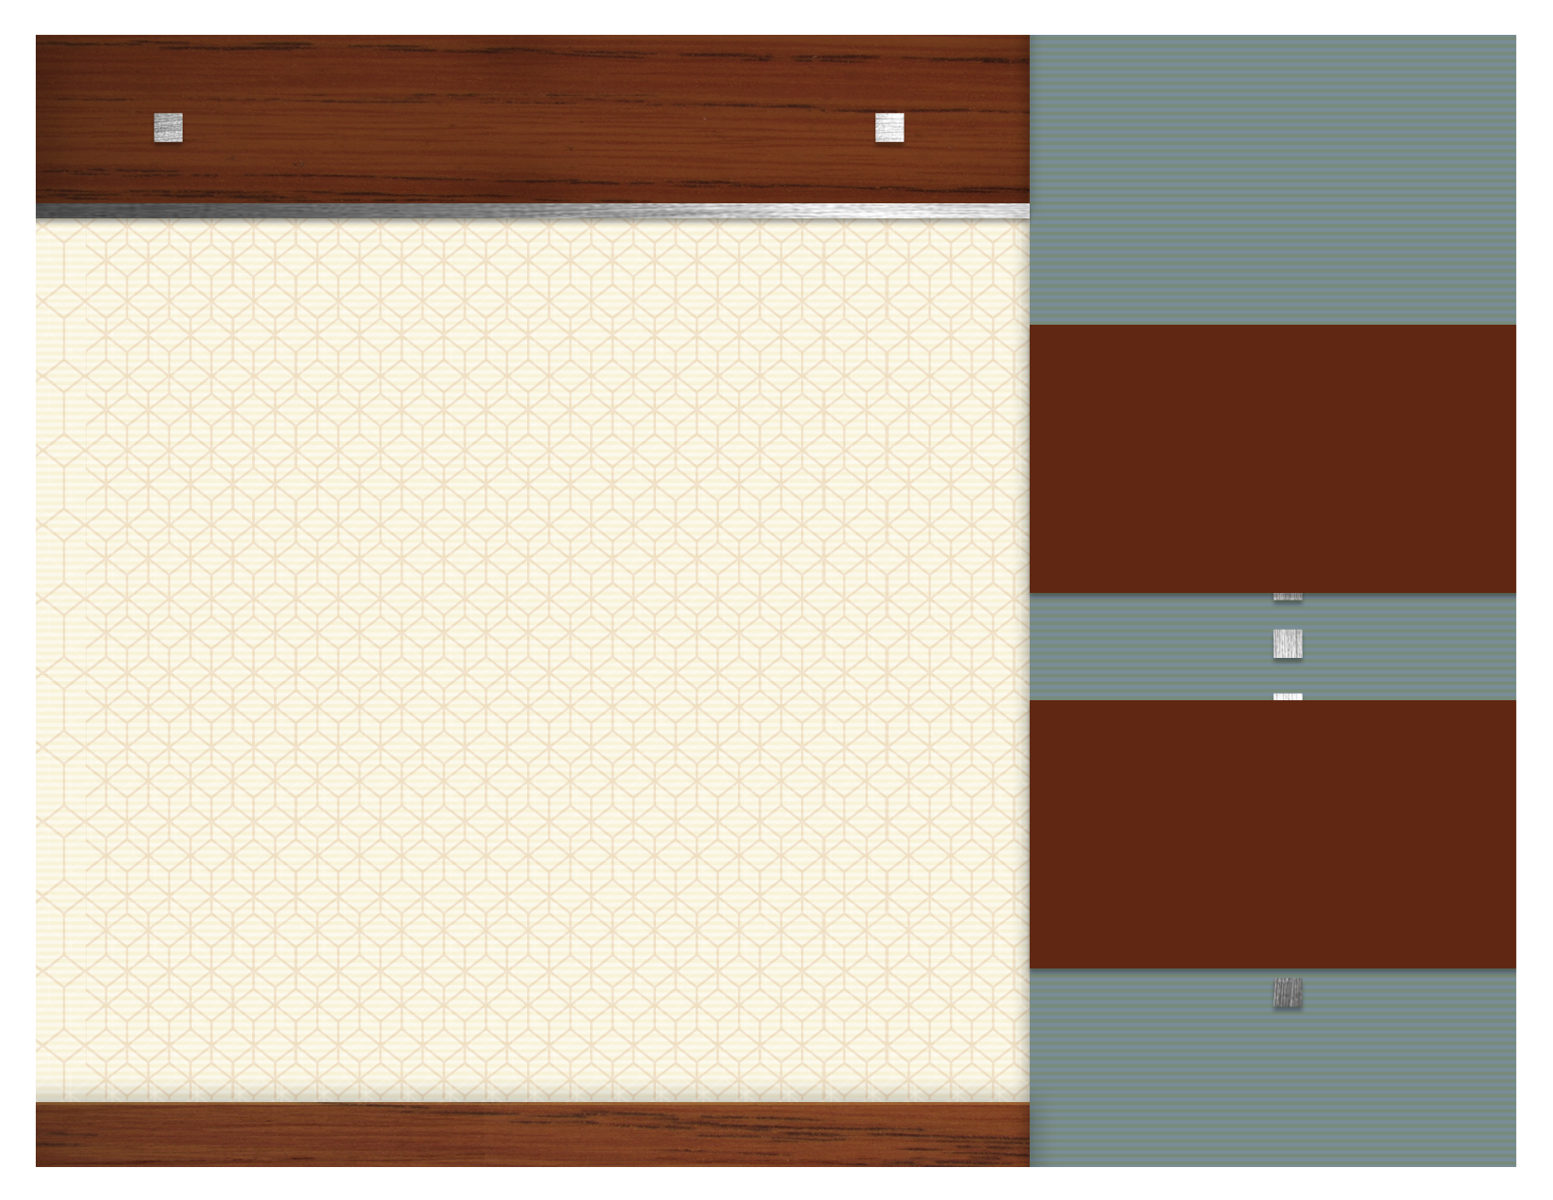
March focus items

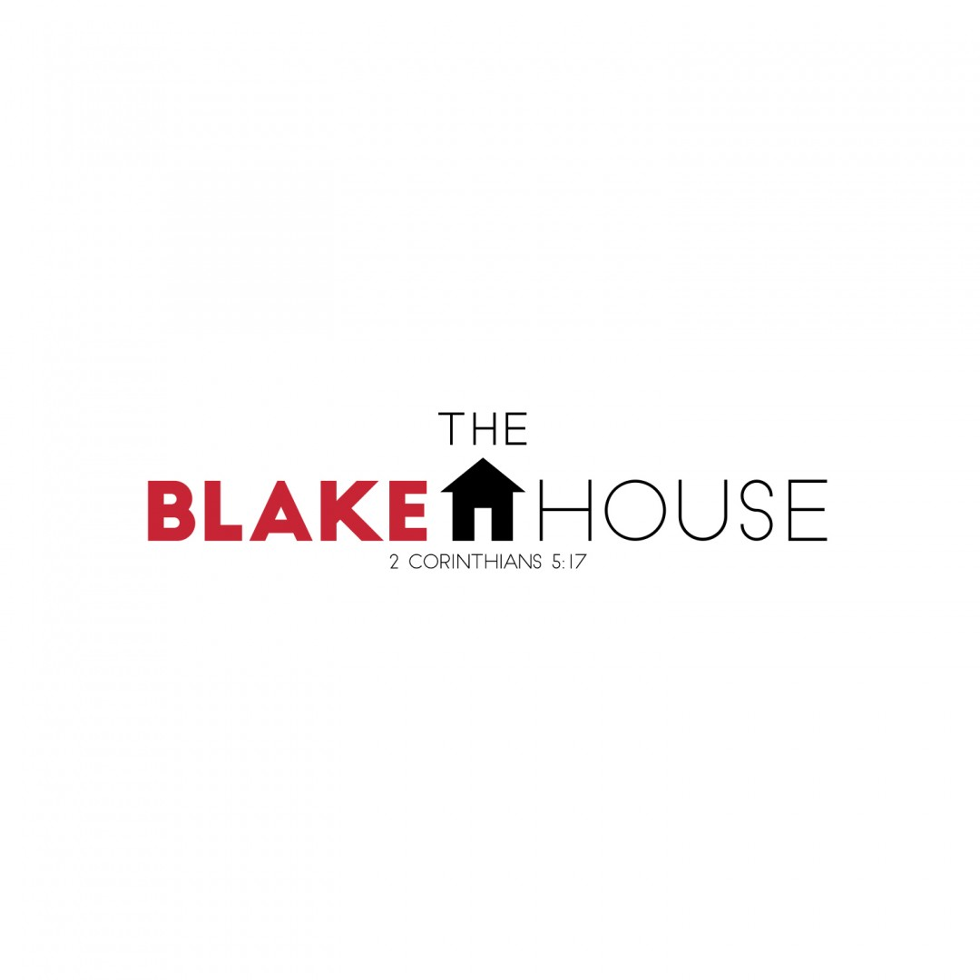

.

HCMS BACKPACK PROGRAM

Saltine/Ritz Crackers
The Blake House

3/4

Sugar

3/11

Toilet Paper

3/18

Hot Sauce

3/25

Tylenol

